**You can also installed the following software’s with default options.**

1. MS Office 2013 – Professional Plus.
2. Visual Studio 2012 - Professional Edition
3. SharePoint Designer 2013
4. Microsoft Visio 2013 - Premium Edition

**Turning off Internet Explorer Enhanced Security Configuration**

Keeping the Internet Explorer Enhanced Security Configuration enabled on your servers is recommended to help ensure that your servers are not inadvertently exposed to malware or other browser-based attacks. However, in some environments you might wish to turn off the Internet Explorer Enhanced Security Configuration protections to enable easier browsing for administrators or standard users.

|  |
| --- |
| **To turn off Internet Explorer Enhanced Security Configuration** |

1. Close any Internet Explorer browser windows that you might have open.
2. Open Server Manager
3. If your server is running Windows Server® 2012, click **Configure this local server** to open the **Local Server** configuration page. Then, in the **Properties** area, next to **IE Enhanced Security Configuration**, click **On** to open the **Internet Explorer Enhanced Security Configuration dialog**.

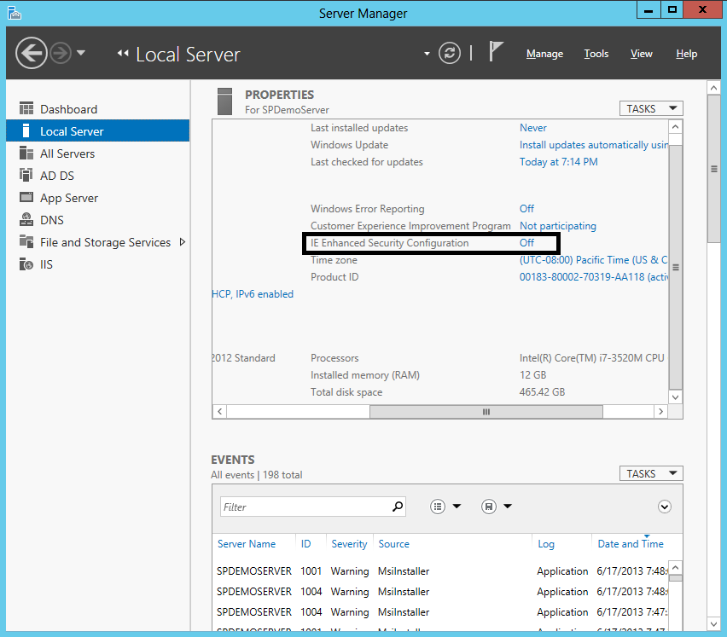

1. To allow members of the local Administrators group to use Internet Explorer in its default client configuration, under **Administrators** click **Off**.
2. To allow members of all other groups to use Internet Explorer in its default client configuration, under **Users** click **Off**.
3. Click **OK** to apply your changes.